Question Answering

Source: https://people.ischool.berkeley.edu/~dbamman/nlp20_slides/22_question_answering.pdf

Knowledge-based (factoid)
- Parse question into a meaningful representation and execute it against a database
- Logical forms to define meaning
  - Combinatory categorial grammar ties syntactic and semantic structure
  - Consists of combinators and lexicon (mapping between syntactic/semantic info)
  - Learn lexicon and CCG parser from lexicon:
    - Need joint probability of logical form L and derivation T for sentence S:
    - Maximize probability of correct denotation y from tree T with logical form z executed against knowledge base K:
  - Limitation: lack of manual mappings (task-specific) and cannot parse out of vocabulary sample not in lexicon

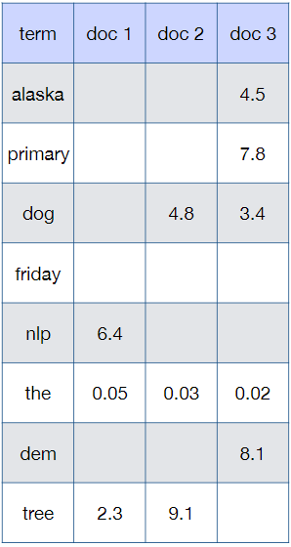
Information-based
- Question processing
  - Answer type detection for higher precision
- Document retrieval
  - Represent query and documents by TF-IDF weighted vector and rank by similarity (e.g. cosine)
  - Rank passages
    - # entities of correct type
    - # question keywords
    - Longest exact sequence of keywords in passage
    - Document rank
    - N-gram overlap
  - Datasets: SquAD, NewsQA, HotspotQA
